Project Part 1 - Common Analysis Reflection Activity

## **Visualization Analysis**

All parts of the common analysis have led the way to some interesting visualizations. There are several insights we can derive from these.

*Produce a histogram showing the number of fires occurring every 50-mile distance from your assigned city up to the maximum specified distance.*

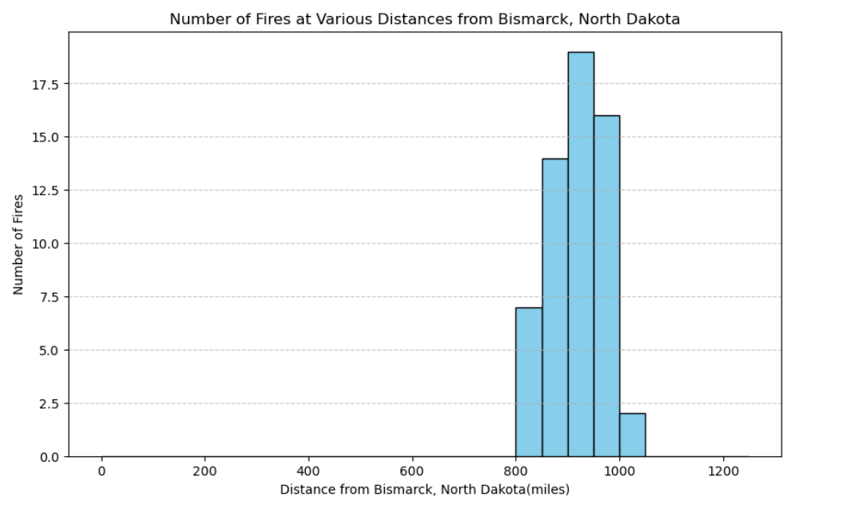

Figure 1: Histogram of the fires at different distances from Bismarck, ND

**Graph Description**:

The graph above represents the histogram of the fires and their distribution over the distance from Bismarck, North Dakota. The histogram illustrates the spatial distribution of fires concerning their occurrence frequency at 50-mile intervals from the assigned city.

**What Does the Figure Show?**

1. Provides a visual representation of the count of fires occurring within predetermined distances up to the specified maximum distance from the city.
2. Provides a trend that might influence further analysis on the cause of fires within a particular spatial location.

**How Does the Viewer “Read” the Figure?**

1. Each bar on the horizontal axis signifies a 50-mile distance range from the assigned city. The height of the bars represents the number of fires occurring within each interval.
2. Interpret the varying heights of the bars to ascertain the density or concentration of fires across different distance bands from the city.

**What Are the Axes, and What Do They Represent?**

Horizontal Axis: Represents distance intervals from the assigned city, grouped at 50-mile increments, showcasing the spatial spread of fires.

Vertical Axis: Indicates the count or frequency of fires occurring within each respective 50-mile interval, reflecting the number of fire occurrences.

**What Is the Underlying Data and How Was It Processed?**

Data Source: The processed data obtained from the GeoJson containing the wildfire attributes across the US led to estimates of the smoke impact on the city of Bismarck.

**Interpretation of the Graph:**

1. The histogram helps us to ascertain the pattern of the wildfires are taking. Provides the information that can be leveraged to assess risk or allocate resources for fire damage management at certain regions
2. Observers analyze the distribution pattern to discern areas or distance bands around the city with higher or lower fire frequency.

*Produce a time series graph of total acres burned per year for the fires occurring in the specified distance from your city.*

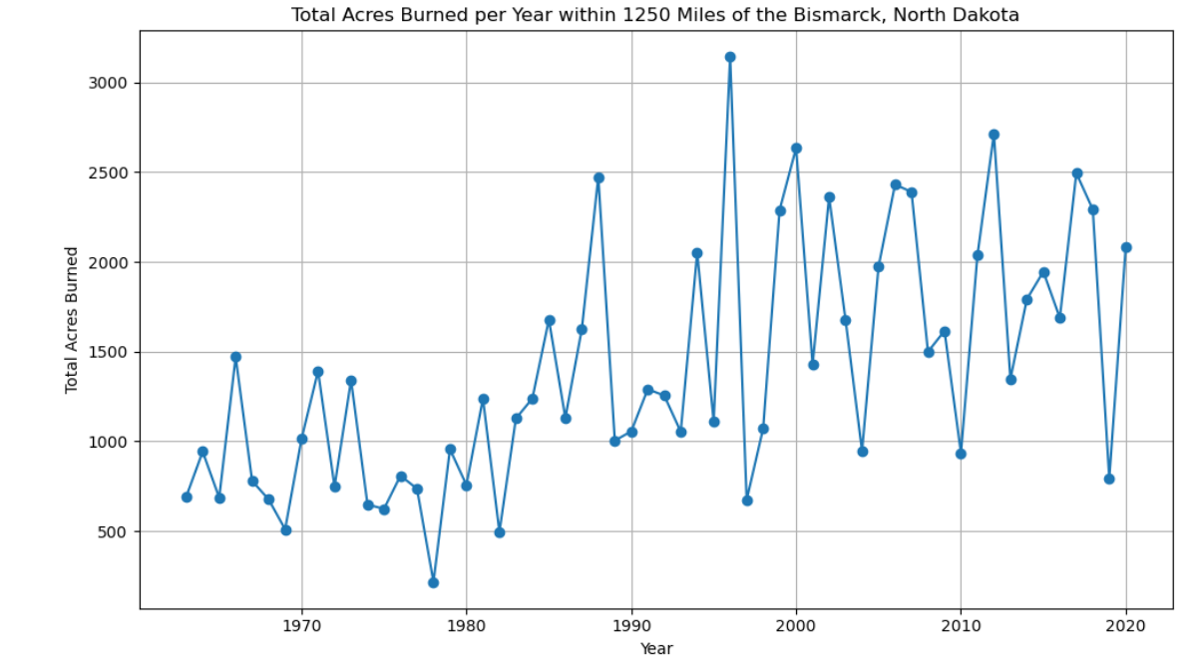

Figure 2: Time series of the total acres burned per year around Bismarck, ND

**Graph Description**:

The graph above represents the time series representation of the total area that burned down during the wildfire. The data was generated in the data analysis part of the common analysis. This is being plotted against the temporal span. The graph considers all the fires that were maximum at a distance of 1250 miles from Bismarck.

**What Does the Figure Show?**

1. The graph exhibits a time series representation of the total acres burned annually by fires proximate to Bismarck.
2. Illustrates the fluctuations and trends in the cumulative acres burned by fires within the specified distance from the city over successive years.

**How Does the Viewer “Read” the Figure?**

Axis Interpretation: The horizontal axis represents the years, providing a chronological sequence of annual observations. The vertical axis signifies the total acres burned in each respective year.

Interpreting Trends: Viewers analyze the temporal trends in total acres burned per year to discern patterns and fluctuations in wildfire activity near the city.

**What Are the Axes, and What Do They Represent?**

Horizontal Axis: Represents time in years, delineating the temporal span of the observations.

Vertical Axis: Depicts the cumulative total acres burned by fires occurring within the specified distance from City X for each respective year.

**What Is the Underlying Data and How Was It Processed?**

Data Source:The processed data obtained from the GeoJson containing the wildfire attributes across the US led to estimates of the smoke impact on the city of Bismarck.

**Interpretation of the Graph:**

1. The time series graph contains the sum of the areas of the fires that were burning in and around a 1250 miles distance from Bismarck.
2. This chart can be used to analyze the impact of wildfires on the local vegetation potentially influencing land management or fire prevention strategies

*Produce a time series graph containing your fire smoke estimate for your city and the AQI estimate for your city.*

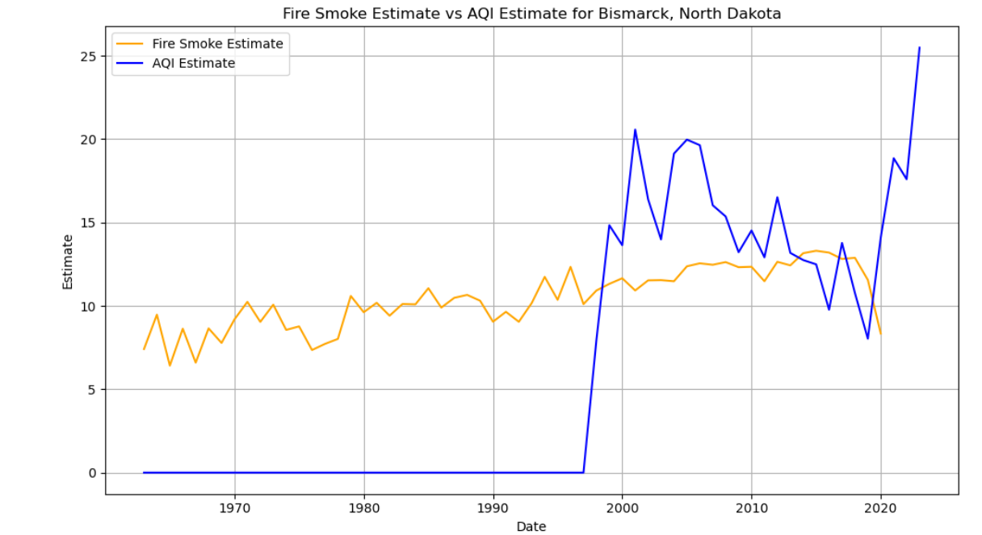

Figure 3: Time series of the calculated smoke estimate vs the AQI estimate for Bismarck, ND

**Graph Description**

The graph above represents the time series representation of the estimated smoke impact that was generated in the data analysis part of the common analysis. This is being plotted against the Air Quality Index estimates that we obtained from the API over the years.

**What Does the Figure Show?**

* The graph displays a time series depiction of the Fire Smoke Estimate and AQI Estimate for Bismarck, North Dakota over a period from 1963 to 2023.
* It showcases the concurrent variation of estimated fire smoke impact and air quality index within the city across time.

**How Does the Viewer “Read” the Figure?**

Axis Interpretation: The horizontal axis represents time, indicating the time progression of the estimates, while the vertical axis denotes the estimated values.

Reading Trends: Observers interpret trends, shifts, or synchronizations between the Fire Smoke Estimate (orange curve) and AQI Estimate (blue curve) for potential correlations or patterns.

**What Are the Axes, and What Do They Represent?**

Horizontal Axis: Time scale, distributed yearly, showcasing the temporal span of the estimates from 1963 to 2023.

Vertical Axis: This represents the estimated values for both Fire Smoke and AQI Estimates index values.

**What Is the Underlying Data and How Was It Processed?**

Data Source: The processed data obtained from the GeoJson containing the wildfire attributes across the US led to estimates of the smoke impact on the city of Bismarck. The AQI estimates were obtained from the API

Processing: The smoke estimates were calculated for each wildfire that was documented from 1963 to 2023. There is a primary focus on the town of Bismarck and the fires in and around it (1250 miles from it).

**Interpretation of the Graph:**

1. The AQI estimates are available only from 1998 onwards and everything before that is 0.
2. The Smoke estimate is only till 2020. There are no wildfires recorded close to or in Bismarck.
3. The Smoke estimate is a log-transformed value which is in the order similar to the AQ index.

## 

## **Common Analysis - Reflection**

*We would like to understand what you got out of the collaborative activities in this assignment. You should write a reflection statement that highlights one or two specific things that you learned from answering the research question posed in this assignment. How did the possibility of collaboration help, hinder, or change your thinking about the problem? Your reflection statement should include specific attributions for all code, methods, and techniques that you reused. Your reflection statement should be no more than two written pages.*

Common Analysis having the same theme as the rest of the class allowed some amount of collaboration in terms of brainstorming approach and also in discussing technical issues. The research question although fairly straightforward had a significant amount of technical processing behind it which required collaboration with peers. The codes that were provided as the guidelines by Professor McDonald were a comprehensive starting point that helped us all navigate through technologies we had not been aware of. Throughout this project, I have appreciated the diversity in thinking people bring to the table and how it has helped me hone my approach to problem-solving.

**Takeaways from the research question.**

The project mainly focused on the impact of wildfires on a city assigned to us. The city I was assigned was Bismarck, North Dakota. The impact was an abstract topic that needed more direction for further analysis and the impact needed to be quantified to make an impression on any stakeholder. The research question gave the analysis a direction by asking us to quantify the impact of wildfires on Bismarck. We had to calculate or estimate the smoke impact on our city from the wildfires that occurred in and around a radius of 1250 miles of our assigned city. The purpose of this estimated smoke impact is that it is an indicator of the overall health of the city and can have serious repercussions on the health, tourism, economic, or other social problems that result from the smoke.

To me, the pieces of the analysis seemed very disjointed and didn’t flow in well together. We have a dataset that documents the wildfires over a long period and across a big span of land. The GeoJson I was asked to refer to contained information on all the wildfires across the US. The logical next goal from this data was to estimate the smoke impact and subsequently consider the potential social and economic impacts of the smoke. On the surface, it seemed disconnected, but after careful consideration seemed to fit together. The wildfire attributes or data could be used to create a relationship based on their impact on the smoke generation. This relationship can be quantified and represented in terms of a mathematical equation and this generic rule can be applied to all the fires. The subsequent impact smoke can have on social and economic conditions could be the function of smoke in impacting avenues like tourism. Thus the quantification of the smoke impact can direct the policy makers towards problematic areas that could lead to the reforms and policies.

Takeaway 1: My main takeaway from this was that earlier I used to view a project as a module and would seldom think about the bigger picture. When I approached this project, I just limited my outlook to analyzing the data and getting results out. However, once I discussed with my peers why the smoke impact estimate was important and its role in the city, I was able to find relationships between the fields. The data was no longer just columns and matrices, they became factors that impact humans. From a purely mathematical or analytical approach to solving any problem, the common analysis taught me how to measure impact on society.

Takeaway 2: My other takeaway from this project was the way to quantify relationships into a mathematical formula that can be applied to different situations. I used to find the formulae that we studied puzzling, always wondering how they came to be. With this project, we were asked to build a smoke estimate for each wildfire. This helped me to visualize all the factors in a space and convert their impact into a math formula. The cherry on the cake was when we compared our estimates with the AQI, it gave me a sneak peek into how the AQI might be calculated in reality.

**How did the possibility of collaboration help, hinder, or change your thinking about the problem?**

The possibility of collaboration helped me greatly in thinking about the problem. As previously stated, the collaboration helped me piece together the big picture. I was able to extrapolate meaning from seemingly related variables given to me and was able to create a viable estimate that could be leveraged to guide decision-making and policies. The collaboration helped me think about the project holistically and changed my approach to the solution.

In addition to the approach, collaboration helped me with my technical implementation issues. We were all on the same page concerning the data and the analysis. By discussing our approaches and by putting across the pros and cons of each stage, we were able to navigate through the project without a lot of issues.

**Your reflection statement should include specific attributions for all code, methods, and techniques that you reused.**

I would like to credit the contribution of the following people in helping me out with this project.

- Dr. David W. McDonald - for providing code snippets that acted as guidelines in navigating newer APIs that I didn’t particularly have experience with.

- Aviva Munshi - for collaborating with the project approach and for providing technical assistance with the operational issues when I faced issues.

- Rhea Sharma - for collaborating with the project approach and for providing technical assistance with the operational issues when I faced issues.

- Nizan Howard - for collaborating with the project approach and for providing technical assistance with the operational issues when I faced issues.